公司地址: Lumina Voyage Tech Pte. Ltd.
联系方式: 135 MIDDLE ROAD, #02-16, BYLANDS BUILDING, SINGAPORE 188975
邮箱/ws号码: yugq2022@gmail.com; 65-85064986 (这个邮箱和电话号码后期会改)；Instagram: luminavoyagetech; Facebook: Lumina Voyage Tech
公司logo:

介绍: (以下内容你看哪些合适就使用哪些)

(A) Brief introduction

LUMINA VOYAGE TECH PTE. LTD., incorporated in 2025, leverages an exclusive partnership with the original equipment manufacturer (OEM) of the photo booths to ensure reliable and professional service from the outset. Our OEM partner has extensive experience with successful deployments in China, Southeast Asia, and other international markets, and will provide end-to-end support including technical guidance, remote monitoring, proactive maintenance, and rapid on-site assistance.

This collaboration guarantees maximum uptime and a consistently positive customer experience. As one of the first offerings of its kind in Singapore, our product provides travellers with a novel and engaging experience that enhances social media appeal and aligns with CapitaLand’s reputation for innovation and entertainment. In summary, our proposal combines the agility of a new enterprise with the proven expertise of an established industry leader. This partnership reduces operational risks and ensures customers to receive a service that meets the highest standards of reliability and quality.

(B) Range of Products
- Key Product Categories & Price Ranges (excl. GST):

Our core product is a unified, signature "Singapore Souvenir Newspost" experience, offered at a single attractive price point to encourage impulse purchases and streamline the customer journey. All packages include both physical and digital components.

Primary Product Category: Souvenir Newspaper Photo Experience

Price: S$6.99 (per session, exclusive of GST)

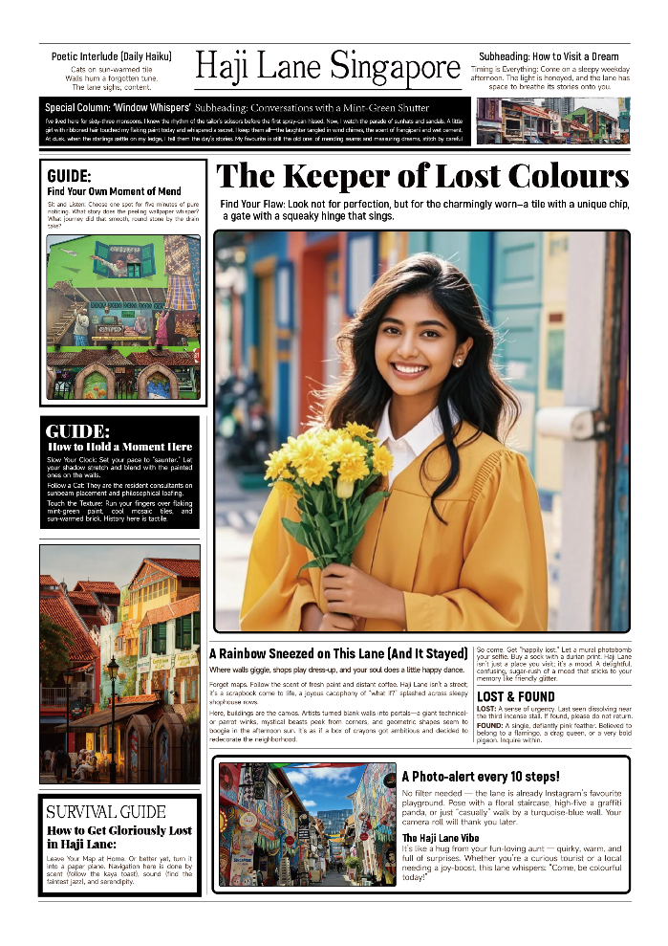

Description: A quick, seamless, and fun self-service photo experience. Customers receive: (1) One high-quality physical newspaper-style print: Features a custom-designed backdrop of a specific Singapore attraction (e.g., Marina Bay Sands, Gardens by the Bay, Clark Quay, Haji Lane, Changi Airport) with catchy, engaging headlines and date stamps tailored for social media sharing and as a unique physical souvenir.

(2) Digital copy download: A high-resolution digital version of the photo is instantly delivered to the customer's mobile device via a QR code, facilitating immediate sharing on social media platforms (Instagram, TikTok, Facebook, Douyin).

Operational Concept: The offer is a unified, one-price product, making the service incredibly simple and fast for passengers. The entire process is designed to be completed in under one minute, aligning with the fast-paced bar environment.

Pricing Policy Confirmation: We confirm that the selling price of our Souvenir Newspaper Photo Experience will be maintained at S$6.99 (excl. GST) and will not exceed the pricing of comparable photo-based souvenir experiences within comparable outlets.

(C) Design & Concept, Capital Expenditure
- Proposed Brand Name: LUMINA VOYAGE (光旅)
- Concept Features:
  - Touch-screen interface with multi-language support
  - Step-by-step operation guideline (Only a few seconds to take a picture)
  - NFC and QR code payment options: supporting VISA/MasterCard/JCB, Discover/Diners, U.P. Union Pay, Alipay, GrabPay, PayNow QR, SingTel Dash, WeChat Pay, ShopeePay.
  - Interactive product recommendations based on flight destination
  - Augmented reality preview of souvenirs
- Vending Machine Specifications:
  - Dimensions: 2.175m (H) x 0.925m (W) x 1.850m (D)
  - 255 product capacity
  - Room temperature
  - Energy-efficient LED lighting
  - Remote monitoring and inventory management system
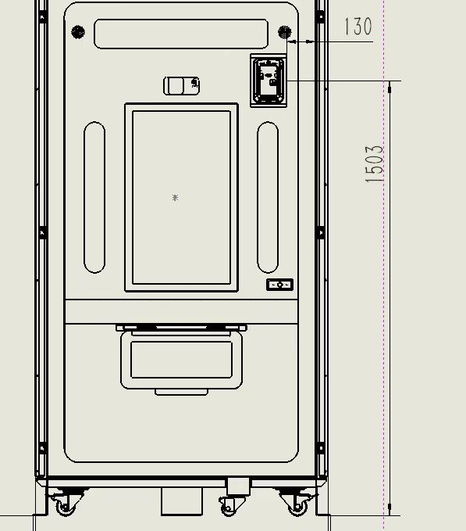

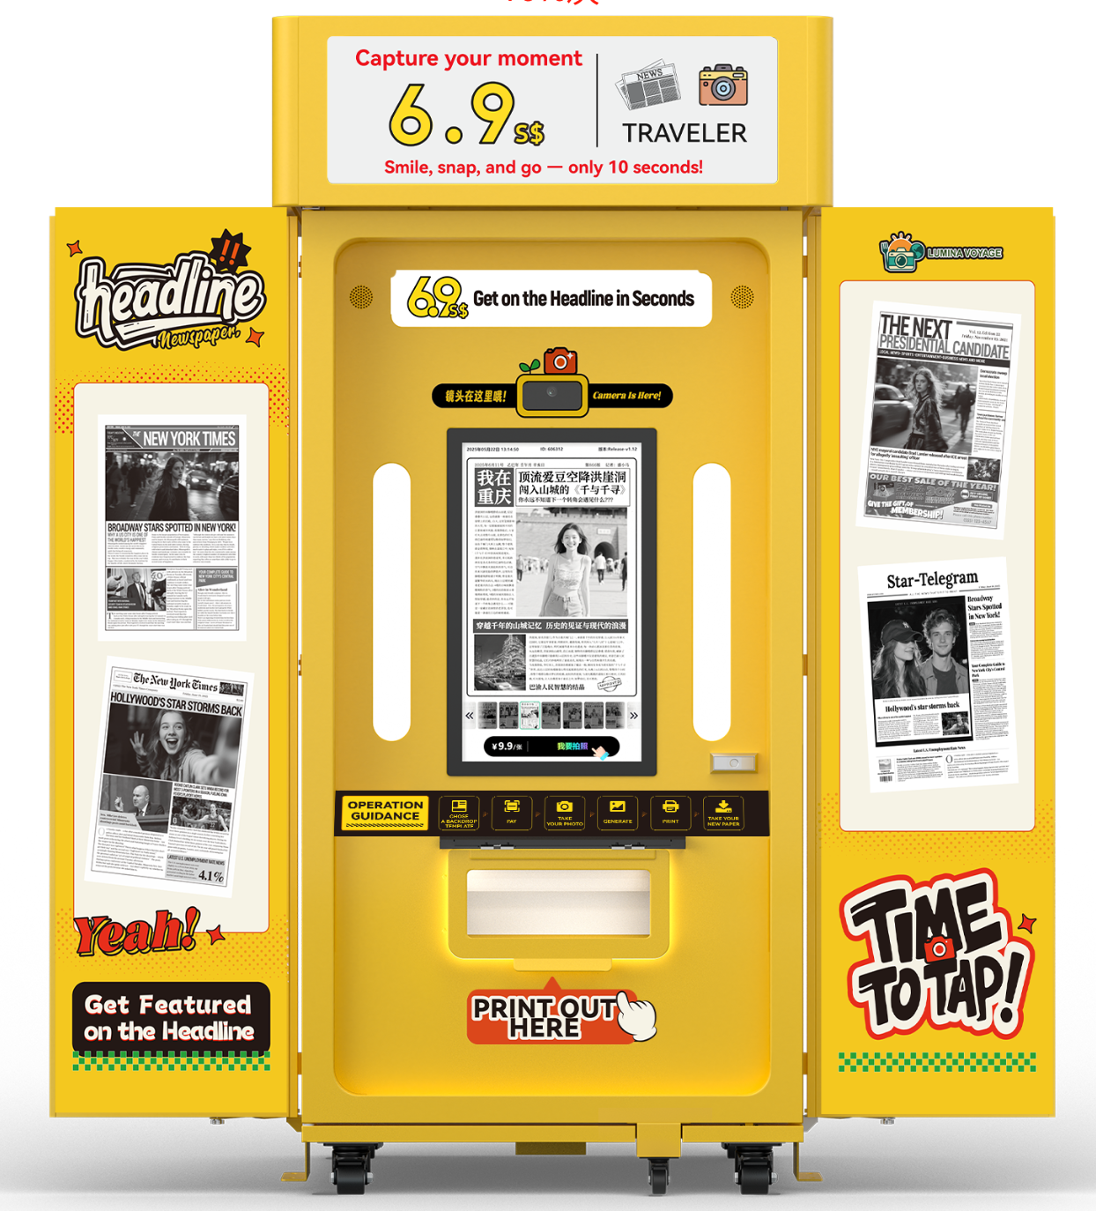

(D) Customer Service
We are committed to delivering a seamless and positive customer experience through clearly defined, technology-driven standard operating procedures (SOPs).
1. User Guidance & Operation
- Simplified step-by-step instructions are visibly displayed on the machine surface, ensuring an intuitive and user-friendly experience.
2. Remote Monitoring & Proactive Management
- The self-service photo booth is equipped with real-time remote monitoring capabilities. This allows our system administrators to continuously track machine status, performance, and consumable levels (e.g., paper), enabling proactive maintenance before issues arise.
3. Maintenance Schedule
To ensure consistent performance and longevity of the equipment, we adhere to a strict, multi-tiered maintenance schedule:
Daily Maintenance:
- Perform a diagnostic check on the system's operational status.
- Verify the remaining levels of consumables (e.g., photo paper).
Monthly Maintenance:
- Lubricate mechanical components such as door locks and gears.
- Inspect and tighten any loose fasteners and connections.
- Wipe down and clean the external surfaces of the unit.
- Check and calibrate touch screen sensitivity.
Annual Maintenance:
- Clean the radiator guard and internal ventilation systems.
- Perform a comprehensive calibration and full-system diagnostic.
- Test and inspect the main circuit control board for optimal performance.
- Perform all tasks outlined in the Monthly and Daily Maintenance checklists.

(G) Management and Operation
- Operational Monitoring: ALLUMINA VOYAGE staff will oversee the machine’s daily operations to ensure smooth and reliable performance.
- Supply Replenishment: Paper and other consumables will be replenished periodically as required.
- Routine Maintenance: Preventive maintenance will be conducted on a regular schedule to maintain optimal functionality.
- Technical Support: Any malfunctions or technical issues will be promptly addressed to minimize downtime.

(H) Pricing Policy

We hereby formally confirm our understanding and unconditional acceptance of these terms. Our pricing strategy will be rigorously managed to ensure that:
- The GST-exclusive selling price of every item in our concession will be set at or below the price of the same item at any designated Comparable Outlet.
- This practice will be maintained consistently for the duration of our agreement.

(I) Our Undertaking
- We undertake to comply with all safety, security, and operational regulations as per Key Terms.

公司历程 （公司成立时间较短，这部分就不用了）:
照片/视频:

资质: 不用

证书: 不用
团队/办公/厂房照片: 还在收集中

详细产品资料（名称，描述，主图，详情图，参数，规格等）。
